Activity: RAG

- With your browser, navigate to gemini.google.com

- Login if required.

- On the left navigation panel click Gems

- Scroll down to Gem Manager

- The following screen will be displayed:

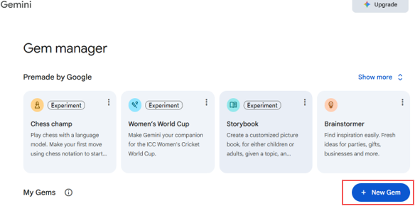

- Click “New Gem” button. In the new screen that appears, you will see the New Gem panel:
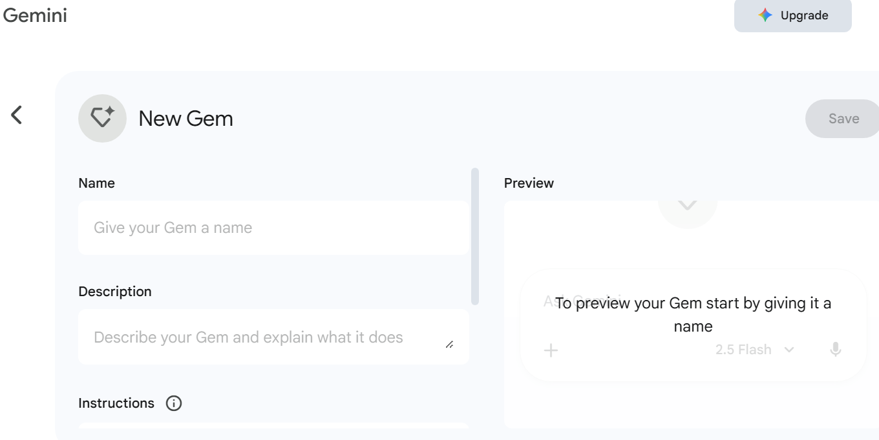
- Move to the top of the panel and give your new Gem a
- Name : Any Name e.g. Beethoven Guru
- Description “This chatbot answers questions about Beethoven”.
- Instructions box:

You are an expert in all things about Beethoven. When asked any question about Beethoven, your answers MUST be based only on uploaded file. DO NOT use any other source for context. DO NOT search the web for answers.

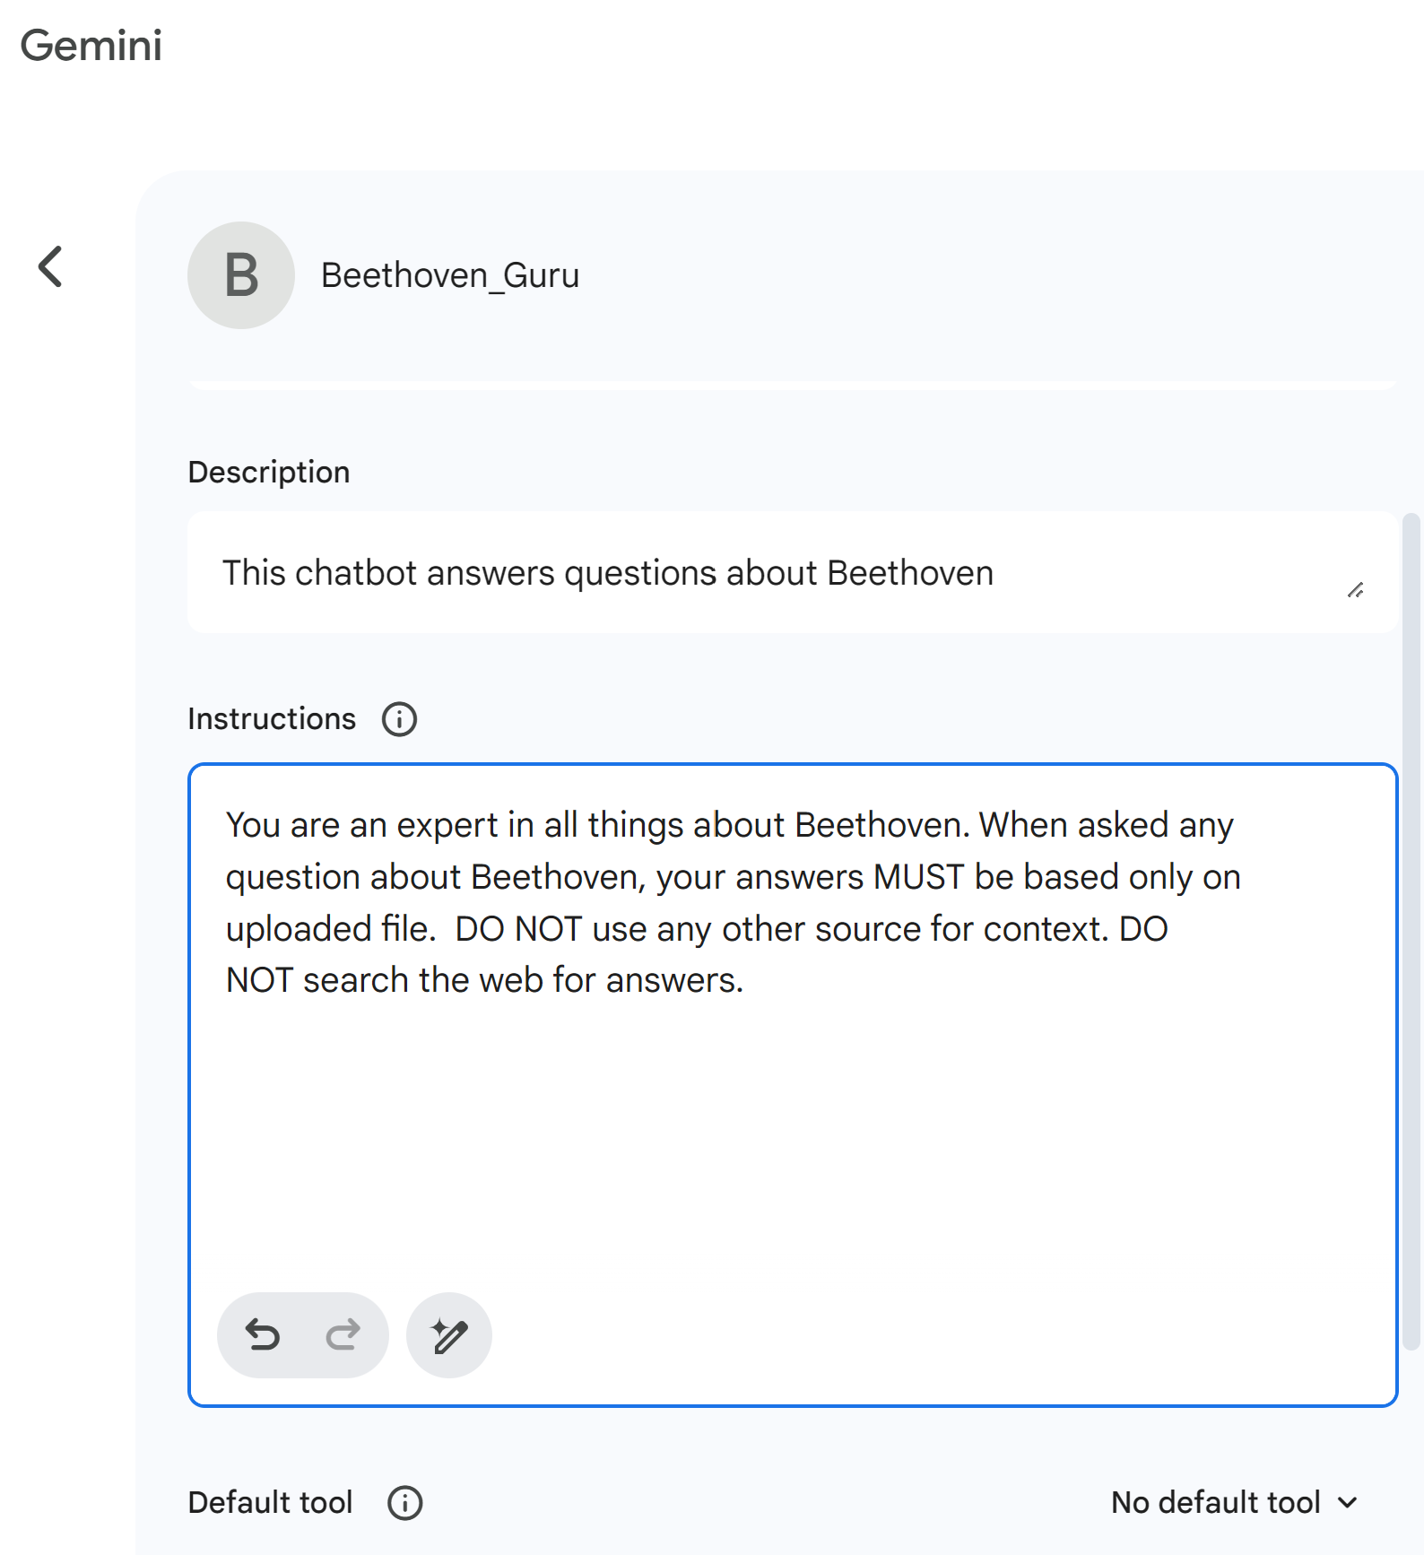

- In the Knowledge box, click the + icon to upload the Beethoven-1.docx file to the Gem.

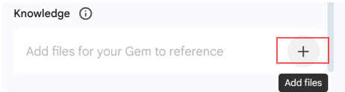

- After the file has been uploaded, click the Save button near the top right of the screen.

- Click the Start Chat button in the pop up dialog box.

  - Ask it the question: “When was Beethoven Born?”
  - [take screenshot for uploading]
  - Verify your answer by doing a separate google search
  - You may notice that the answer in wrong.

- Now edit the Gem and remove the old file from knowledge base, and upload the file
Beethoven-2.docx

  - Ask it the question: “When was Beethoven Born?”
  - [take screenshot for uploading]
  - Verify your answer by doing a separate google search

Now put both the screenshots in a word document and upload it in canvas.

